**1D Numpy in Python**

### Create a Python List as follows:

*# Create a python list*

a = ["0", 1, "two", "3", 4]

We can access the data via an index:

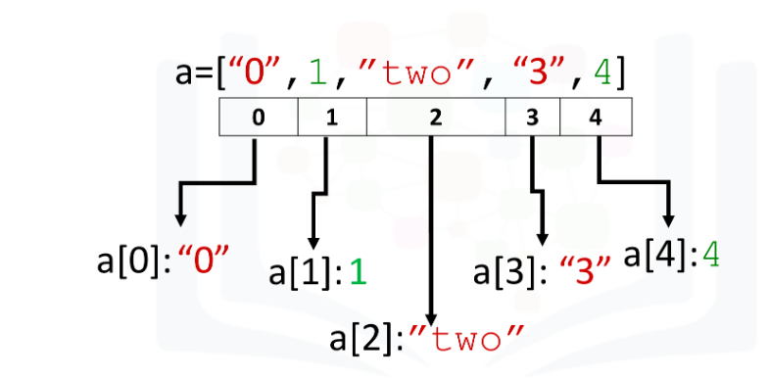

We can access each element using a square bracket as follows:

*# Print each element*

print("a[0]:", a[0])

print("a[1]:", a[1])

print("a[2]:", a[2])

print("a[3]:", a[3])

print("a[4]:", a[4])

a[0]: 0

a[1]: 1

a[2]: two

a[3]: 3

a[4]: 4

## What is Numpy?

NumPy is a Python library used for working with arrays, linear algebra, fourier transform, and matrices.A numpy array is similar to a list. NumPy stands for Numerical Python and it is an open source project.The array object in NumPy is called **ndarray**, it provides a lot of supporting functions that make working with ndarray very easy.

Arrays are very frequently used in data science, where speed and resources are very important.

NumPy is usually imported under the np alias.

It's usually fixed in size and each element is of the same type. We can cast a list to a numpy array by first importing numpy:

*# import numpy library*

import numpy as np

We then cast the list as follows:

*# Create a numpy array*

a = np.array([0, 1, 2, 3, 4])

a

array([0, 1, 2, 3, 4])

Each element is of the same type, in this case integers:

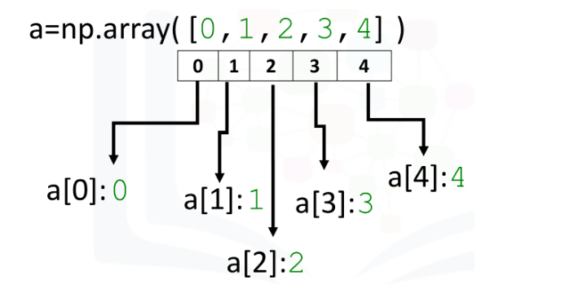

As with lists, we can access each element via a square bracket:

*# Print each element*

print("a[0]:", a[0])

print("a[1]:", a[1])

print("a[2]:", a[2])

print("a[3]:", a[3])

print("a[4]:", a[4])

### Checking NumPy Version

The version string is stored under **version** attribute.

print(np.__version__)

1.22.3

### Type

If we check the type of the array we get **numpy.ndarray**:

*# Check the type of the array*

type(a)

numpy.ndarray

As numpy arrays contain data of the same type, we can use the attribute "dtype" to obtain the data type of the array’s elements. In this case, it's a 64-bit integer:

*# Check the type of the values stored in numpy array*

a.dtype

dtype('int32')

### Try it yourself

Check the type of the array and Value type for the given array **b:**

b = np.array([3.1, 11.02, 6.2, 213.2, 5.2])

*# Enter your code here*

type(b)

numpy.ndarray

b.dtype

dtype('float64')

Assign value

We can change the value of the array. Consider the array c:

*# Create numpy array*

c = np.array([20, 1, 2, 3, 4])

c

array([20, 1, 2, 3, 4])

We can change the first element of the array to 100 as follows:

*# Assign the first element to 100*

c[0] = 100

c

array([100, 1, 2, 3, 4])

We can change the 5th element of the array to 0 as follows:

*# Assign the 5th element to 0*

c[4] = 0

c

array([100, 1, 2, 3, 0])

### Slicing

Like lists, we can slice the numpy array. Slicing in python means taking the elements from the given index to another given index.

We pass slice like this: [start:end].The element at end index is not being included in the output.

We can select the elements from 1 to 3 and assign it to a new numpy array d as follows:

*# Slicing the numpy array*

d = c[1:4]

d

array([1, 2, 3])

We can assign the corresponding indexes to new values as follows:

*# Set the fourth element and fifth element to 300 and 400*

c[3:5] = 300, 400

c

array([100, 1, 2, 300, 400])

We can also define the steps in slicing, like this: [start:end:step].

arr = np.array([1, 2, 3, 4, 5, 6, 7])

print(arr[1:5:2])

[2 4]

If we don't pass start its considered 0

print(arr[:4])

[1 2 3 4]

If we don't pass end it considers till the length of array.

print(arr[4:])

[5 6 7]

If we don't pass step its considered 1

print(arr[1:5:])

[2 3 4 5]

### Assign Value with List

Similarly, we can use a list to select more than one specific index. The list select contains several values:

*# Create the index list*

select = [0, 2, 3, 4]

select

[0, 2, 3, 4]

We can use the list as an argument in the brackets. The output is the elements corresponding to the particular indexes:

*# Use List to select elements*

d = c[select]

d

array([100, 2, 300, 400])

We can assign the specified elements to a new value. For example, we can assign the values to 100 000 as follows:

*# Assign the specified elements to new value*

c[select] = 100000

c

array([100000, 1, 100000, 100000, 100000])

### Other Attributes

Let's review some basic array attributes using the array a:

*# Create a numpy array*

a = np.array([0, 1, 2, 3, 4])

a

array([0, 1, 2, 3, 4])

The attribute size is the number of elements in the array:

*# Get the size of numpy array*

a.size

5

The next two attributes will make more sense when we get to higher dimensions but let's review them. The attribute ndim represents the number of array dimensions, or the rank of the array. In this case, one:

*# Get the number of dimensions of numpy array*

a.ndim

1

The attribute shape is a tuple of integers indicating the size of the array in each dimension:

# Get the shape/size of numpy array

a.shape

(5,)

### Numpy Statistical Functions

*# Create a numpy array*

a = np.array([1, -1, 1, -1])

*# Get the mean of numpy array*

mean = a.mean()

mean

0.0

*# Get the standard deviation of numpy array*

standard_deviation=a.std()

standard_deviation

1.0

*# Create a numpy array*

b = np.array([-1, 2, 3, 4, 5])

b

array([-1, 2, 3, 4, 5])

*# Get the biggest value in the numpy array*

max_b = b.max()

max_b

5

*# Get the smallest value in the numpy array*

min_b = b.min()

min_b

-1

## Numpy Array Operations

You could use arithmetic operators directly between NumPy arrays

Array Addition

Consider the numpy array u:

u = np.array([1, 0])

u

array([1, 0])

Consider the numpy array v:

v = np.array([0, 1])

v

array([0, 1])

We can add the two arrays and assign it to z:

# Numpy Array Addition

z = np.add(u, v)

z

array([1, 1])

The operation is equivalent to vector addition:

# Plotting functions

import time

import sys

import numpy as np

import matplotlib.pyplot as plt

%matplotlib inline

def Plotvec1(u, z, v):

ax = plt.axes() # to generate the full window axes

ax.arrow(0, 0, *u, head_width=0.05, color='r', head_length=0.1)# Add an arrow to the U Axes with arrow head width 0.05, color red and arrow head length 0.1

plt.text(*(u + 0.1), 'u')#Adds the text u to the Axes

ax.arrow(0, 0, *v, head_width=0.05, color='b', head_length=0.1)# Add an arrow to the v Axes with arrow head width 0.05, color red and arrow head length 0.1

plt.text(*(v + 0.1), 'v')#Adds the text v to the Axes

ax.arrow(0, 0, *z, head_width=0.05, head_length=0.1)

plt.text(*(z + 0.1), 'z')#Adds the text z to the Axes

plt.ylim(-2, 2)#set the ylim to bottom(-2), top(2)

plt.xlim(-2, 2)#set the xlim to left(-2), right(2)

# Plot numpy arrays

Plotvec1(u, z, v)

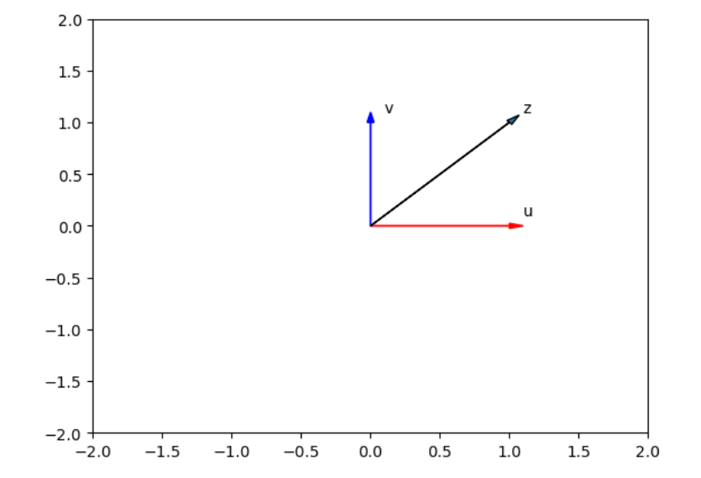

### Array Subtraction[¶](https://cf-courses-data.s3.us.cloud-object-storage.appdomain.cloud/jupyterlite/lab/index.html?notebook_url=https%3A%2F%2Fcf-courses-data.s3.us.cloud-object-storage.appdomain.cloud%2FIBMDeveloperSkillsNetwork-PY0101EN-SkillsNetwork%2Flabs%2FModule%25205%2FPY0101EN-5-1-Numpy1D.ipynb#Array-Subtraction)

Consider the numpy array a:

a = np.array([10, 20, 30])

a

array([10, 20, 30])

Consider the numpy array b:

b = np.array([5, 10, 15])

b

array([ 5, 10, 15])

We can subtract the two arrays and assign it to c:

c = np.subtract(a, b)

print(c)

[ 5 10 15]

### Array Multiplication

Consider the vector numpy array y:

*# Create a numpy array*

x = np.array([1, 2])

x

array([1, 2])

*# Create a numpy array*

y = np.array([2, 1])

y

array([2, 1])

We can multiply every element in the array by 2:

*# Numpy Array Multiplication*

z = np.multiply(x, y)

z

array([2, 2])

### Array Division

Consider the vector numpy array a:

a = np.array([10, 20, 30])

a

Consider the vector numpy array b:

b = np.array([2, 10, 5])

b

We can divide the two arrays and assign it to c:

c = np.divide(a, b)

c

array([5., 2., 6.])

### Dot Product[¶](https://cf-courses-data.s3.us.cloud-object-storage.appdomain.cloud/jupyterlite/lab/index.html?notebook_url=https%3A%2F%2Fcf-courses-data.s3.us.cloud-object-storage.appdomain.cloud%2FIBMDeveloperSkillsNetwork-PY0101EN-SkillsNetwork%2Flabs%2FModule%25205%2FPY0101EN-5-1-Numpy1D.ipynb#Dot-Product)

The dot product of the two numpy arrays u and v is given by:

X = np.array([1, 2])

Y = np.array([3, 2])

*# Calculate the dot product*

np.dot(X, Y)

7

*#Elements of X*

print(X[0])

print(X[1])

1

2

*#Elements of Y*

print(Y[0])

print(Y[1])

3

2

We are performing the dot product which is shown as below

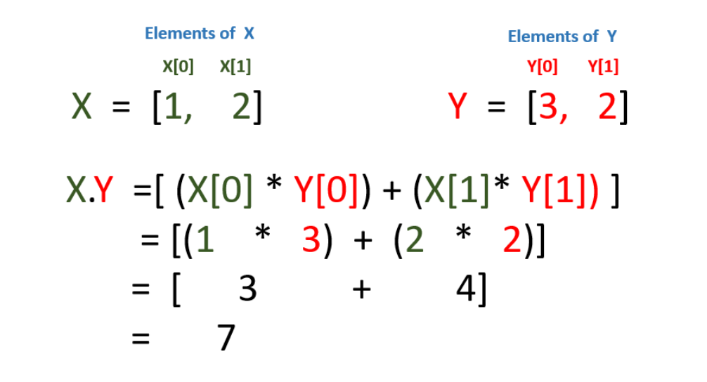

### Adding Constant to a Numpy Array[¶](https://cf-courses-data.s3.us.cloud-object-storage.appdomain.cloud/jupyterlite/lab/index.html?notebook_url=https%3A%2F%2Fcf-courses-data.s3.us.cloud-object-storage.appdomain.cloud%2FIBMDeveloperSkillsNetwork-PY0101EN-SkillsNetwork%2Flabs%2FModule%25205%2FPY0101EN-5-1-Numpy1D.ipynb#Adding-Constant-to-a-Numpy-Array)

Consider the following array:

*# Create a constant to numpy array*

u = np.array([1, 2, 3, -1])

u

Adding the constant 1 to each element in the array:

*# Add the constant to array*

u + 1

The process is summarised in the following animation:

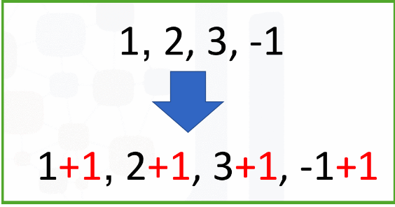

## Mathematical Functions

We can access the value of pi in numpy as follows :

*# The value of pi*

np.pi

3.141592653589793

We can create the following numpy array in Radians:

*# Create the numpy array in radians*

x = np.array([0, np.pi/2 , np.pi])

We can apply the function sin to the array x and assign the values to the array y; this applies the sine function to each element in the array:

*# Calculate the sin of each elements*

y = np.sin(x)

y

array([0.0000000e+00, 1.0000000e+00, 1.2246468e-16])

## Linspace

A useful function for plotting mathematical functions is linspace. Linspace returns evenly spaced numbers over a specified interval.

**numpy.linspace(start, stop, num = int value)**

start : start of interval range

stop : end of interval range

num : Number of samples to generate.

*# Makeup a numpy array within [-2, 2] and 5 elements*

np.linspace(-2, 2, num=5)

array([-2., -1., 0., 1., 2.])

If we change the parameter num to 9, we get 9 evenly spaced numbers over the interval from -2 to 2:

array([-2. , -1.5, -1. , -0.5, 0. , 0.5, 1. , 1.5, 2. ])

We can use the function linspace to generate 100 evenly spaced samples from the interval 0 to 2π:

*# Make a numpy array within [0, 2π] and 100 elements*

x = np.linspace(0, 2*np.pi, num=100)

We can apply the sine function to each element in the array x and assign it to the array y:

*# Calculate the sine of x list*

y = np.sin(x)

*# Plot the result*

plt.plot(x, y)

[<matplotlib.lines.Line2D at 0x43589f0>]

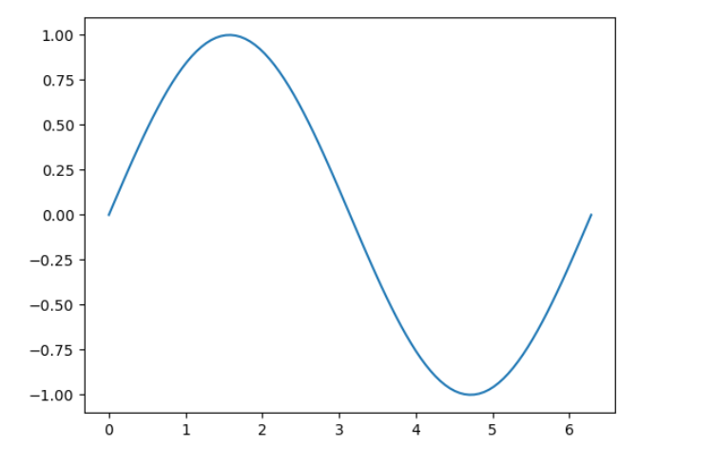

### Iterating 1-D Arrays

Iterating means going through elements one by one.

If we iterate on a 1-D array it will go through each element one by one.

If we execute the numpy array, we get in the array format

arr1 = np.array([1, 2, 3])

print(arr1)

[1 2 3]

But if you want to result in the form of the list, then you can use for loop:

for x in arr1:

print(x)